Loan Application Status Prediction

Problem Statement:
This dataset includes details of applicants who have applied for loan. The dataset includes details like credit history, loan amount, their income, dependents etc.
Independent Variables:
- Loan_ID
- Gender
- Married
- Dependents
- Education
- Self_Employed
- ApplicantIncome
- CoapplicantIncome
- Loan_Amount
- Loan_Amount_Term
- Credit History
- Property_Area
Dependent Variable (Target Variable):
- Loan_Status

We will start our project by importing the important libraries and the data-set itself.
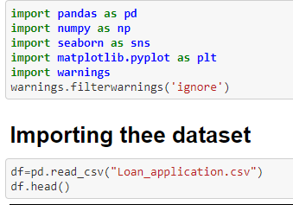

Data Analysis
We can start our Data Analysis process by exploring this dataset, for example we can check the datatype, features, size/shape of our dataset.

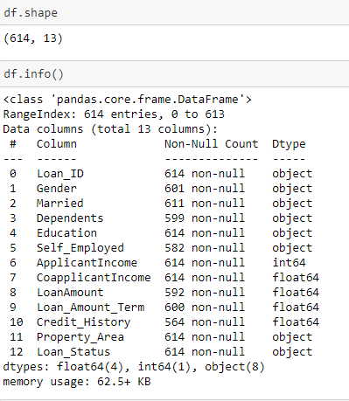
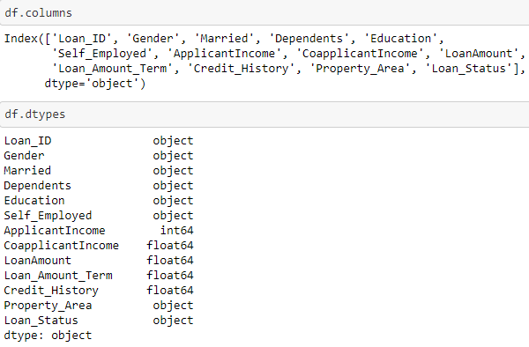
Checking the missing values in the dataset is also one of the primary tasks that we need to do.

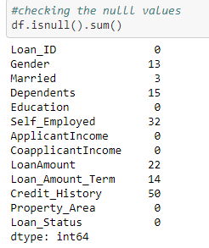

We can see we have a number of missing values in our dataset.

As the size of dataset is not very large, we can’t lose more data.

Hence we can fill these missing values using:-

Categorical data:- Mode

Continous data:- Mean

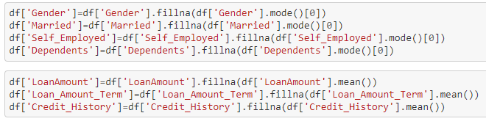

We can check the null values again using heatmap:-

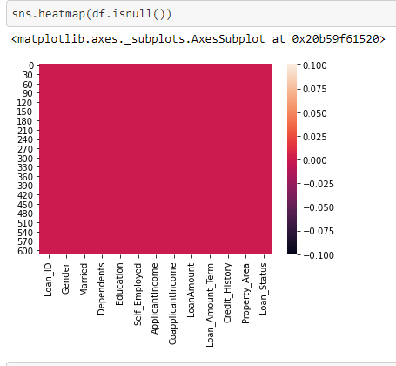

We can check the statistical values of the continous data using .describe method:-

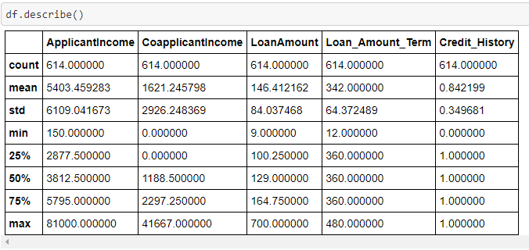

Visualization of the data:-

After Visualizing the data we found following points:-

- Majority of Loan Applicants are Males
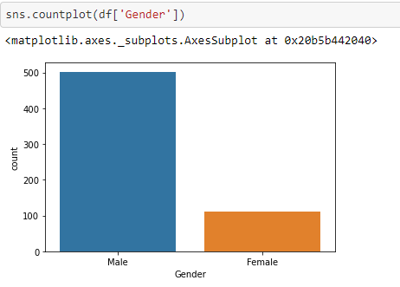

- Majority of Loan Applicants are Married.

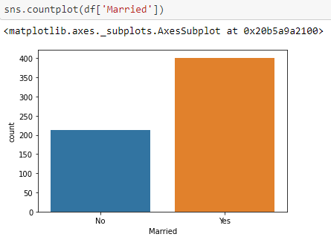
- Majority of Loan Applicants don’t have dependents.

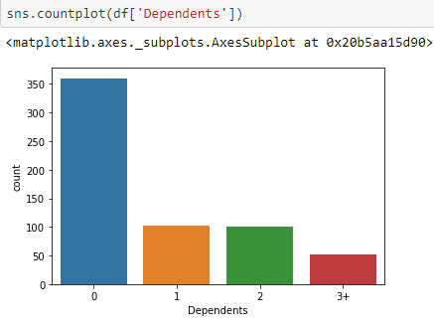
4. Majority of Loan Applicants are Graduate

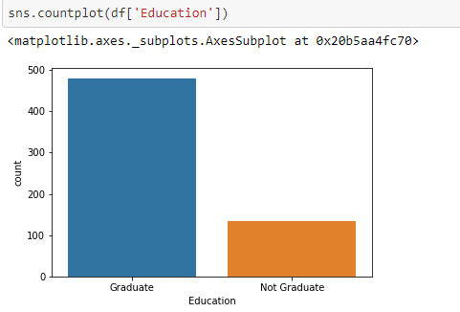

- Majority of Loan applicants are not self employed.

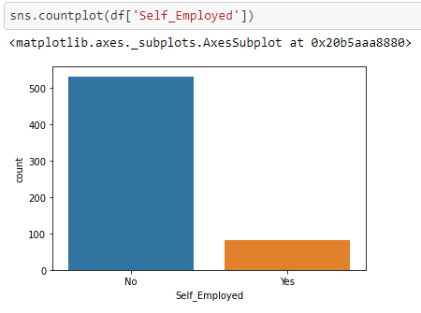
- Majority of Applicants have income between zero to ten thousand

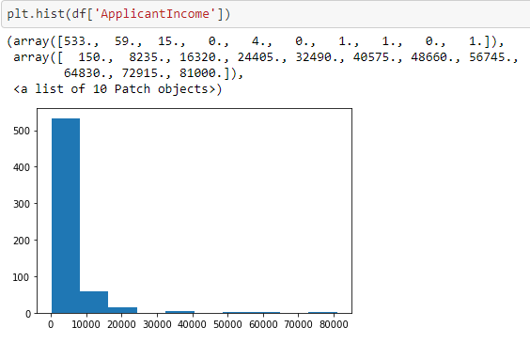
- There is not a very large difference in Loan applicants area-wise, however still Urban area applicants are dominating.

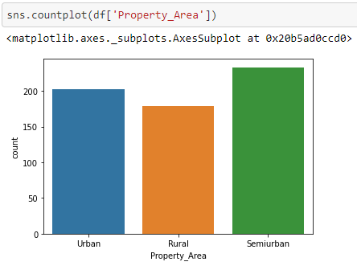

- Majority of the Loan applications are getting approved.

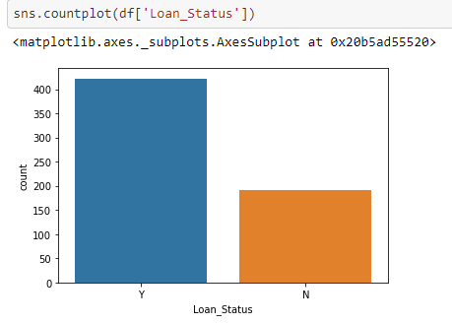

Pre Processing Pipeline:-

We will start by converting the categorical data using Label Encoding.

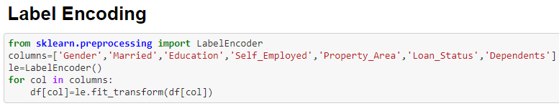

Then we will Drop the unnecessary column to improve accuracy of the model.

In this case, we will be dropping Loan_ID column.

Train Test Split

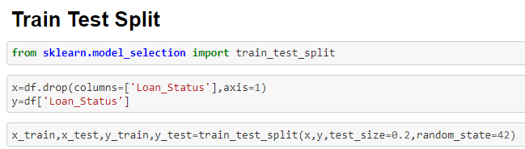

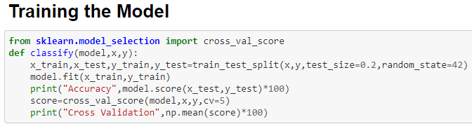

Building a Model:-

We will be testing the dataset using different models and then will finalizing the final model by looking at the most accurate model.

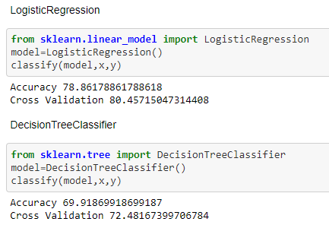

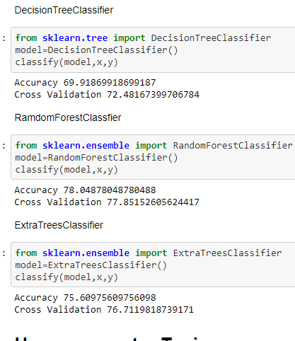

We have tested 5 different models, out of which Random Forest and Extra Trees classifier is giving us the best results.
We will be doing Hyper-parameter on these two models.

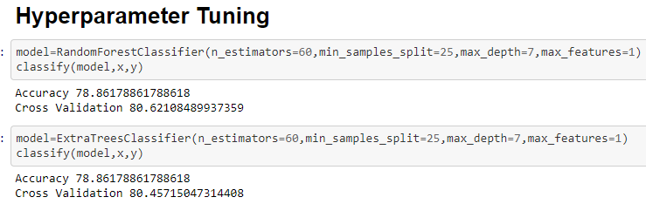

Random Forest Classifier is slightly better.
Hence we will be finalizing this model as our best model.

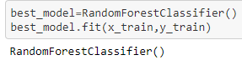

Saving the model:-

We can save the best model using pickle.

